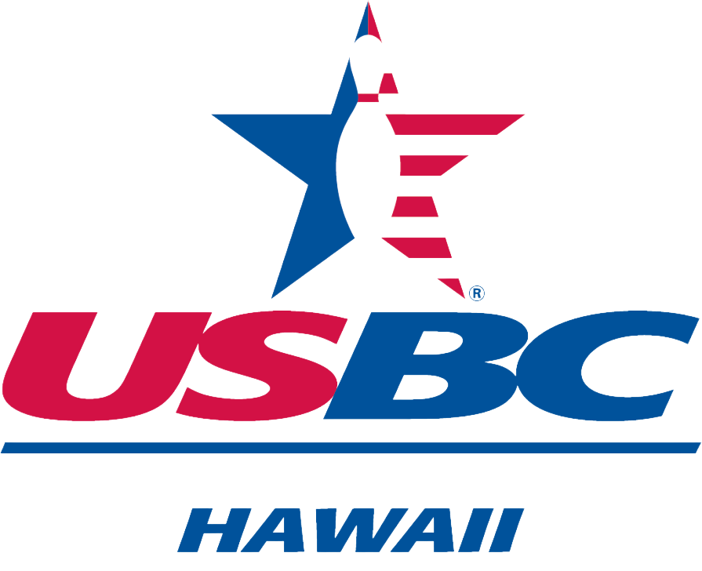 HAWAII USBC ASSOCIATION
HALL OF FAME NOMINATION
MERITORIOUS SERVICE

Date _____________
Name of Nominee__________________________________________________
Address ______________________________________________________________________
USBC Member I.D.________________ Phone _______________/Email Address_________________
*Nominee must have been a HAWAII USBC (OUSBC, OWBA & OBA) member for at least 25 years.
Number of years as a:
Association Director _____
Association President _____
Association Vice President ____
Association Manager ____
Association Committee Chair ____
League Secretary ______
Number of years as:
League Secretary ____
Certified Coach ____
Other relevant information:
____________________________________________________________________________________
____________________________________________________________________________________
NOTE: People who contributed to the sport of bowling on Oahu in other ways (such as Owners, Managers and Coaches should be considered in this category. Their selection should come from a nomination from a member and a special recommendation from the HOF committee.

Nominated by: ___________________________/USBC No.___________ Phone ___________________
Email Address: ___________________________________
Address: _______________________________________________Relationship ___________________
NOTE: It is the responsibility of the nominator to provide any additional information to the Committee. Include with the nomination form a MANDATORY narrative which will tell the selection comittee what is special about this Nominee, and why they should be selected for induction into the OAHU USBC Hall of Fame. Hand deliver or mail no later than April 15th to: HAWAII USBC Hall of Fame Committee, 95-390 3A Kuahelani Ave, Mililani, HI 96789

