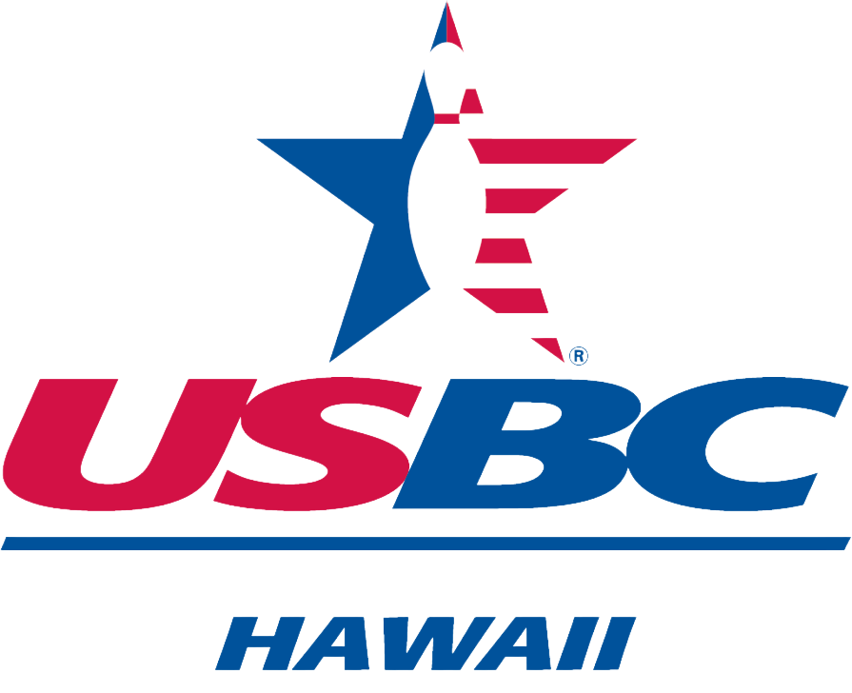 HAWAII USBC ASSOCIATION
HALL OF FAME NOMINATION
BOWLING ACHIEVEMENT

Date _____________
Name of Nomimee______________________________________________________________
Address ______________________________________________________________________
USBC Member I.D.________________ Phone _____________________________
*Nominee must have been a HAWAII USBC (OUSBC, OWBA & OBA) member for at least 25 years.
No. of City championship tournaments ______
No. of other City association tournaments ______
Local titles ___________________________________________________________________________
____________________________________________________________________________________
Number of state championship tournaments ____
State titles ___________________________________________________________________________
Number of national tournaments ____
National achievements of note __________________________________________________________

Number of years with average of (200 for Men, and 180 for women) ____
No. of 300 games ____
No. of 800 series ____
No. of 700 series ____

Nominated by: ___________________________/USBC No.___________ Phone ___________________
Email Address: ___________________________________
Address: _______________________________________________Relationship ___________________
NOTE: It is the responsibility of the nominator to provide any additional information to the Committee. Include with the nomination form a MANDATORY narrative which will tell the selection committee what is special about this Nominee, and why they should be selected for induction into the OAHU USBC Hall of Fame. Hand deliver or mail no later than April 15th to: HAWAII USBC Hall of Fame Committee, 95-390 3A Kuahelani Ave, Mililani, HI 96789

